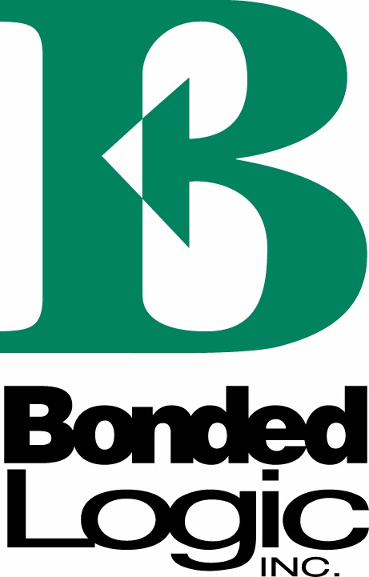

For Immediate Release: Contact:
July 26, 2012 Chris Fiscus
(602) 254-7312

UltraTouchTM Denim Insulation Expanding Across West
Green and sustainable insulation will now be in Lowe’s stores

CHANDLER, Ariz. – UltraTouchTM Denim Insulation will be available in 165 Lowe’s stores across the western United States starting Aug. 6, announced Bonded Logic, a leading manufacturer of insulation products.

UltraTouch Denim Insulation is made from blue jeans and other recycled textiles. The insulation offers customers maximum thermal performance and superior sound-reducing qualities with a 30- to 50-percent increase in sound absorption. As an additional benefit, the insulation offers a new life for post-consumer blue jeans, rather than sending them to the landfill.

“We’re seeing an increased demand for sustainable and green insulation products, and the partnership with Lowe’s will help us to introduce UltraTouch to customers all across the West,”
said Sean Desmond, Sales and Marketing Director for Bonded Logic.

Lowe’s will offer R-13 and R-19 insulation in the 165 stores, and customers can special order R-21 and R-30.

The insulation does not contain added formaldehyde, Volatile Organic Compounds (VOC) or chemical irritants and requires no warning labels compared to other traditional insulation products. UltraTouch is easy to handle and work with because there is no “installation itch” common with fiberglass insulation. Also, a portion of each package contains perforations that allow consumers to tear the insulation by hand, similar to a paper towel.

Learn more about UltraTouch and Bonded Logic at www.bondedlogic.com

###

About Bonded Logic, Inc.
With more than 35 years of insulation experience, Bonded Logic markets and manufactures a wide range of thermal and acoustical insulation products for multiple industries. Based in Chandler, Ariz., Bonded Logic offers a superior performing natural fiber product to meet every insulation need, while keeping consumers and the environment safe and healthy. The company is best known for its UltraTouch Denim Insulation – sourced entirely of post-consumer blue jeans and free of harsh chemicals. Bonded Logic is an OEM supplier to leading manufacturers in various industries. Bonded Logic’s products are widely available throughout the United States. For more information or to find a distributor, visit www.bondedlogic.com.

